
National University Of Modern Languages, Islamabad

User Experience Design (UXD)

Lab Task 10

Task: mart app

Name: Zulqarnain Hassan
Class: 6A Afternoon
Roll no: SP-21379
Assigned Date: 17 March 2025
Deadline: 18 March 2025
Figma Design Link: https://www.figma.com/design/5jCtVxiOwlpKD2tyHX7IhI/university_websit?node-id=250-800&t=Mk8gCGxMpq2fFuA5-1
Marks Obtained
Remarks

Issues:

Design Screenshots:
Screen 1
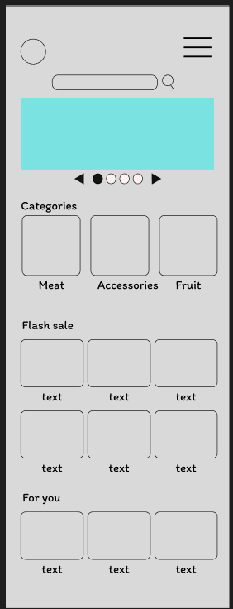

Screen 1
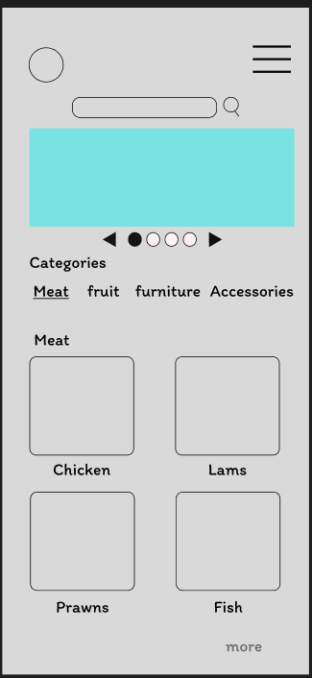

Screen 1
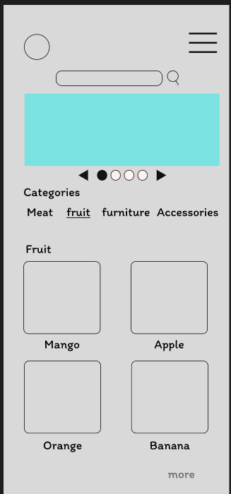

Screen 1
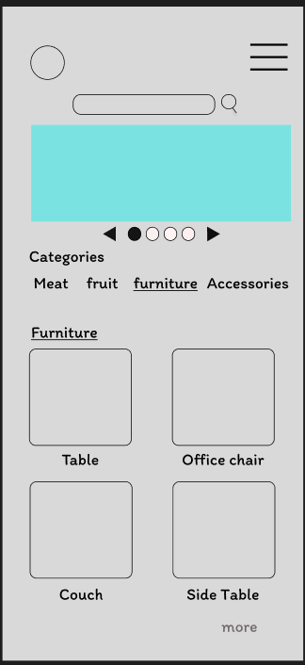

Screen 1
